**DAIRY VALUE CHAINS**

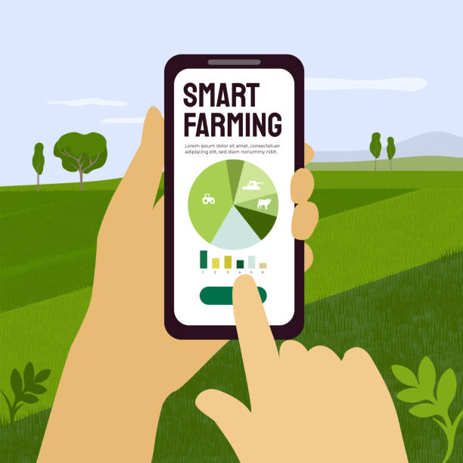

**PRODUCT PROCESS BY TECH MARVELS**

**10TH JUNE 2024**

**Bridget Kathure | Nancy Nabacwa | Karen Philip | Gloria Nyaga | Pearl Cheshari**

**Table of Content**

**Background 3**

**Testing Goals(Wezesha Mobile App) 3**

Testing Participants 3

Testing Scenarios 4

Logistical Requirements 4

Testing Script 4

## Background

We are providing a web app and dashboard that integrates with cooperatives and SACCOs. Wezesha will give farmers complete access to their documents, including their daily milk productivity, deliveries, and sales transactions.

Wezesha is a solution that will address the challenges faced by smallholder farmers in accessing loans due to a lack of formal financial records and credit history, as well as over-dependence on cooperatives for record-keeping.

This digital trail of farmers' financial activities will then be used to build their credit history and assess their creditworthiness, making the loan acquisition process faster and more efficient for both farmers and SACCOs.

## Testing Goals (Wezesha Mobile App)

**Farmers**

* To identify any challenges a farmer might face when logging in to the app.
* To find out if farmers can input their daily produce
* To find out if farmers can view their recent transactions
* To identify whether farmers can view their loan repayment history

**SACCO**

* To assess the loan officer’s ability to log in to the web portal.
* To evaluate if the officer can input the farmers’ credentials
* To find out whether they can access the farmer’s data

### **Testing Participants**

1. Five farmers.
2. Two cooperative managers
3. Two SACCO loan officers.

### **Testing Scenarios**

**FARMERS**

| **Testing Goals** | **Scenario** | **Success Criteria** |
| --- | --- | --- |
| To successfully register and have an account with Wezesha | Imagine you heard about Wezesha, a digital platform that allows farmers to manage their milk production and sales. You want to have an account on Wezesha to start tracking your milk records and transactions.  How would you go about it through the app? | Successful completion of the registration process.  Easy access to the milk records and transactions. |

**SACCO**

| **Testing Goals** | **Scenario** | **Success Criteria** |
| --- | --- | --- |
|  |  |  |

### **Logistical Requirements**

* The Wezesha App and Web Portal
* Laptop or Phone
* Timing
* Location
* Notebook and pens

### **Testing Script**

**Welcome note**

Welcome to Wezesha, where we provide farmers with increased access to credit, enabling them to grow their businesses.

We foster a sense of community among farmers more effectively and increase profitability.

**Recording Consent**

We would like to ask for your consent to take pictures or recordings of this session. We would like to assure you that the recordings we take will be used solely for research purposes. If you are uncomfortable with any

**Introduction**

We recognized that smallholder farmers face significant challenges in accessing credit and financial services due to a lack of access to their credit history. We set out to develop a solution that would address these issues and provide farmers with a secure and transparent way to manage their finances. We came up with a **solution**:

**Wezesha** is a solution that addresses the challenges faced by smallholder farmers in accessing loans due to a lack of formal financial records and credit history, as well as over-dependence on cooperatives for record-keeping.

We are aiming to provide a web app and dashboard that integrate with cooperatives and SACCOs. Wezesha will give farmers complete access to their documents, including their daily milk productivity, deliveries, and sales transactions.

**Warm-up Questions**

**Farmer**

1. Have you ever used a mobile app to make payments or carried out any mobile services? If yes, give a brief explanation.

**Cooperative**

**Main Questions (***Based on goals***)**

**Post Testing Questionnaire**